**Calculus Review Questions**

**1.** The following diagram shows part of the graph of the function *f*(*x*)= 2*x*2.

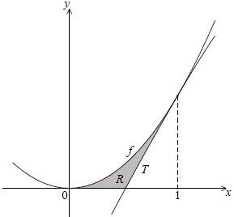

***diagram not to scale***

The line *T* is the tangent to the graph of *f* at *x* = 1.

(a) Show that the equation of *T* is *y* = 4*x* – 2.

(5)

(b) Find the *x*-intercept of *T*.

(2)

(c) The shaded region *R* is enclosed by the graph of *f*, the line *T*, and the *x*-axis.

(i) Write down an expression for the area of *R*.

(ii) Find the area of *R*.

(9)

(Total 16 marks)

**2.** Consider the function *f* with second derivative *f*′′(*x*) = 3*x* – 1. The graph of *f* has a minimum point

at A(2, 4) and a maximum point at B.

(a) Use the second derivative to justify that B is a maximum.

(3)

(b) Given that *f*′ =  – *x* + *p*, show that *p* = –4.

(4)

(c) Find *f*(*x*).

(7)

(Total 14 marks)

**3.** Let *f*(*x*) = *x*3 – 4*x* + 1.

(a) Expand (*x* + *h*)3.

(2)

(b) Use the formula *f*′(*x*) =  to show that the derivative of *f*(*x*) is 3*x*2– 4.

(4)

(c) The tangent to the curve of *f* at the point P(1, –2) is parallel to the tangent at a point Q. Find the coordinates of Q.

(4)

(d) The graph of *f* is decreasing for *p* < *x* < *q*. Find the value of *p* and of *q*.

(3)

(e) Write down the range of values for the gradient of *f*.

(2)

(Total 15 marks)

**4.** Let *f*(*x*) = . Part of the graph of *f* is shown below.

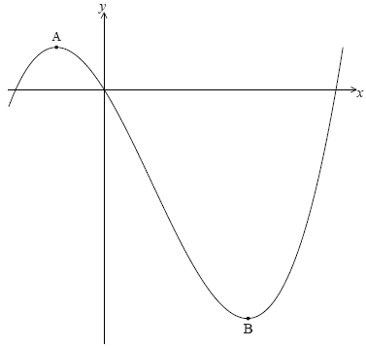

There is a maximum point at A and a minimum point at B(3, –9).

(a) Find the coordinates of A.

(8)

(b) Write down the coordinates of

(i) the image of B after reflection in the *y*-axis;

(ii) the image of B after translation by the vector ;

(iii) the image of B after reflection in the *x*-axis followed by a horizontal stretch with scale factor .

(6)

(Total 14 marks)

**5.** Let *f*(*x*) = *A*e*kx* + 3. Part of the graph of *f* is shown below.

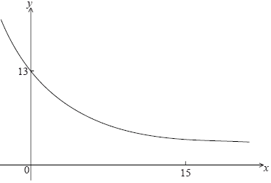

The *y*-intercept is at (0, 13).

(a) Show that *A* =10.

(2)

(b) Given that *f*(15) = 3.49 (correct to 3 significant figures), find the value of *k*.

(3)

(c) (i) Using your value of *k*, find *f*′(*x*).

(ii) Hence, explain why *f* is a decreasing function.

(iii) Write down the equation of the horizontal asymptote of the graph *f*.

(5)

Let *g*(*x*) = –*x*2 + 12*x* – 24.

(d) Find the area enclosed by the graphs of *f* and *g*.

(6)

(Total 16 marks)

**6.** Let *f*(*x*)= *x*3. The following diagram shows part of the graph of *f*.

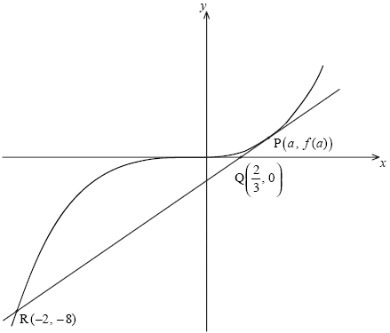

***diagram not to scale***

The point P (*a*, *f*(*a*)), where *a* > 0, lies on the graph of *f*. The tangent at P crosses the *x*-axis at the point Q. This tangent intersects the graph of *f* at the point R(–2, –8).

(a) (i) Show that the gradient of [PQ] is .

(ii) Find *f*′(*a*).

(iii) Hence show that *a* = 1.

(7)

Continues...

...continued

The equation of the tangent at P is *y* = 3*x* – 2. Let *T* be the region enclosed by the graph of *f*, the tangent [PR] and the line *x* = *k*, between *x* = –2 and *x* = *k* where –2 < *k* < 1. This is shown in the diagram below.

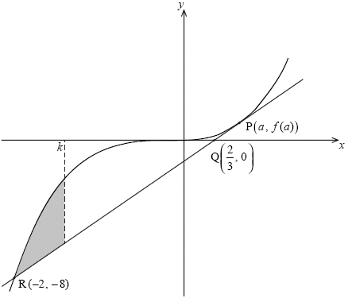

***diagram not to scale***

(b) Given that the area of *T* is 2*k* + 4, show that *k* satisfies the equation *k*4 – 6*k*2 + 8 = 0.

(9)

(Total 16 marks)

**7.** Let *f*(*x*) = . Line *L* is the normal to the graph of *f* at the point (4, 2).

(a) Show that the equation of *L* is *y* = –4*x* + 18.

(4)

(b) Point A is the *x*-intercept of *L*. Find the *x*-coordinate of A.

(2)

In the diagram below, the shaded region *R* is bounded by the *x*-axis, the graph of *f* and the line *L*.

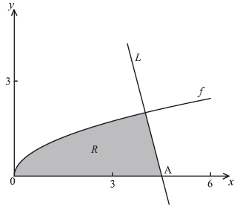

(c) Find an expression for the area of *R*.

(3)

(d) The region *R* is rotated 360° about the *x*-axis. Find the volume of the solid formed, giving your answer in terms of π.

(8)

(Total 17 marks)

**8.** Let *f* : *x*  sin3 *x*.

(a) (i) Write down the range of the function *f*.

(ii) Consider *f* (*x*) =1, 0  *x*  2. Write down the number of solutions to this equation. Justify your answer.

(5)

(b) Find *f* ′ (*x*), giving your answer in the form *a* sin*p* *x* cos*q* *x* where *a*, *p*, *q*  .

(2)

(c) Let *g* (*x*) =  for 0  *x*  . Find the volume generated when the curve of *g* is revolved through 2 about the *x*-axis.

(7)

(Total 14 marks)

**9.** The acceleration, *a* m s–2, of a particle at time *t* seconds is given by *a* = 2*t* + cos*t*.

(a) Find the acceleration of the particle at *t* = 0.

(2)

(b) Find the velocity, *v*, at time *t*, given that the initial velocity of the particle is 2 m s–1.

(5)

(c) Find , giving your answer in the form *p* – *q* cos 3.

(7)

(d) What information does the answer to part (c) give about the motion of the particle?

(2)

(Total 16 marks)

**10.** Let *f* (*x*) = e*x* (1 – *x*2).

(a) Show that *f* ′ (*x*) = e*x* (1 – 2*x* – *x*2).

(3)

Part of the graph of *y* = *f* (*x*), for – 6  *x*  2, is shown below. The *x*-coordinates of the local minimum and maximum points are *r* and *s* respectively.

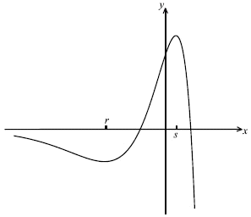

(b) Write down the **equation** of the horizontal asymptote.

(1)

(c) Write down the value of *r* and of *s*.

(4)

(d) Let *L* be the normal to the curve of *f* at P(0, 1). Show that *L* has equation *x* + *y* = 1.

(4)

(e) Let *R* be the region enclosed by the curve *y* = *f* (*x*) and the line *L*.

(i) Find an expression for the area of *R*.

(ii) Calculate the area of *R*.

(5)

(Total 17 marks)

**11.** The function *f* (*x*) is defined as *f* (*x*) = 3 + , *x*  .

(a) Sketch the curve of *f* for −5  *x*  5, showing the asymptotes.

(3)

(b) Using your sketch, write down

(i) the equation of each asymptote;

(ii) the value of the *x*-intercept;

(iii) the value of the y-intercept.

(4)

(c) The region enclosed by the curve of *f*, the *x*-axis, and the lines *x* = 3 and *x* = *a*, is revolved through 360 about the *x*-axis. Let *V* be the volume of the solid formed.

(i) Find d*x*.

(ii) Hence, given that *V* = , find the value of *a*.

(10)

(Total 17 marks)

**12.** Let *f* (*x*) = , where *p*, *q* +.

Part of the graph of *f*, including the asymptotes, is shown below.

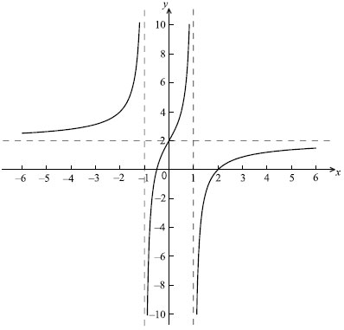

(a) The equations of the asymptotes are *x* =1, *x* = −1, *y* = 2. Write down the value of

(i) *p*;

(ii) *q*.

(2)

(b) Let *R* be the region bounded by the graph of *f*, the *x*-axis, and the *y*-axis.

(i) Find the negative *x*-intercept of *f*.

(ii) Hence find the volume obtained when *R* is revolved through 360 about the *x*-axis.

(7)

(c) (i) Show that *f* ′ (*x*) = .

(ii) Hence, show that there are no maximum or minimum points on the graph of *f*.

(8)

(d) Let *g* (*x*) = *f* ′ (*x*). Let *A* be the area of the region enclosed by the graph of g and the *x*-axis, between *x* = 0 and *x* = *a*, where *a*  0. Given that *A* = 2, find the value of *a*.

(7)

(Total 24 marks)

**13.** Consider the function *f* (*x*) e(2*x*–1) + , *x*  .

(a) Sketch the curve of *f* for −2  *x*  2, including any asymptotes.

(3)

(b) (i) Write down the equation of the vertical asymptote of *f*.

(ii) Write down which one of the following expressions does **not** represent an area between the curve of *f* and the *x*-axis.

 *f* (*x*)d*x*

 *f* (*x*)d*x*

(iii) Justify your answer.

(3)

(c) The region between the curve and the *x*-axis between *x* = 1 and *x* = 1.5 is rotated through 360 about the *x*-axis. Let *V* be the volume formed.

(i) Write down an expression to represent *V*.

(ii) Hence write down the value of *V*.

(4)

(d) Find *f* ′ (*x*).

(4)

(e) (i) Write down the value of *x* at the minimum point on the curve of *f*.

(ii) The equation *f* (*x*) = *k* has no solutions for *p*  *k*  *q*. Write down the value of *p* and of *q*.

(3)

(Total 17 marks)

**14.** Let *f* (*x*) = – *x*2 + *x* + 4.

(a) (i) Write down *f ′* (*x*).

(ii) Find the equation of the normal to the curve of *f* at (2, 3).

(iii) This normal intersects the curve of *f* at (2, 3) and at one other point P.

Find the *x*-coordinate of P.

(9)

Part of the graph of *f* is given below.

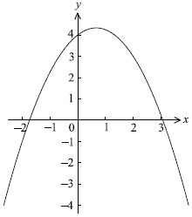

(b) Let *R* be the region under the curve of *f* from *x* = −1 to *x* = 2.

(i) Write down an expression for the area of *R*.

(ii) Calculate this area.

(iii) The region *R* is revolved through 360 about the *x*-axis. Write down an expression for the volume of the solid formed.

(6)

(c) Find  giving your answer in terms of *k*.

(6)

(Total 21 marks)

**15.** The diagram shows part of the graph of *y* = 



(a) Find the coordinates of the point *P*, where the graph meets the *y*-axis.

(2)

The shaded region between the graph and the *x*-axis, bounded by *x* = 0   
and *x* = ln 2, is rotated through 360° about the *x*-axis.

(b) Write down an integral which represents the volume of the solid obtained.

(4)

(c) Show that this volume is .

(5)

(Total 11 marks)