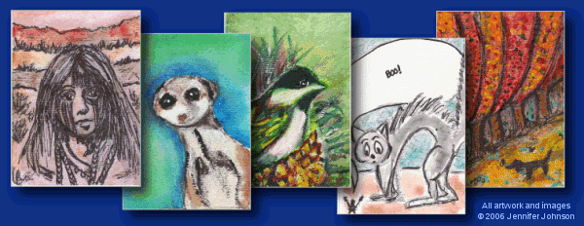

Art 12: Artist trading cards. | Name:

ARTIST TRADING CARDS are a variation of the popular mass-produced trading cards available for sale all over the world. The difference is rather than buying them, you make them. ANY AND ALL MATERIALS and techniques are permitted There is only one rule-- the cards should be the same size as traditional collector cards: 2.5 inches wide by 3.5 inches tall (64mm x 89mm). On the back you should sign and date your cards.

Task:
For this project you will be making a series of 20 Artist Trading cards based around the theme of FAMILY. (If you have another theme you would like to explore, please propose your idea to me!) You will also be required to create and construct a container that will hold your series upon completion. The design of your container should reflect your cards theme.

Expectations:
- 20 unique cards based on your assigned theme
- ATC standards should be followed
- Each Principle of Design is modeled in at least one card of your series
- Mixed media is used throughout.
- USE YOUR RUBRIC AS YOUR GUIDE

Resources to explore:
http://www.artist-trading-cards.ch/ -The original ATC site based in Switzerland
http://www.geocities.com/edsatc/index.html -Ed Beals’ ATC site
http://groups.msn.com/ATCEXCHANGE/ - MSN ATC exchange group
http://www.artjunction.org/atcs.php - A site devoted to ATC’s in the classroom
ATC Learning Targets

To earn a level 3 (80%), your cards should have these qualities:

Concept
- The concept of Dreams is explored beyond clichés.
- There should be clear evidence of thoughtful exploration

Craftsmanship
- Each card is 2.5”x3.5”
- Each card uses a variety of media (screen print, paint, pastels, ink, watercolour) together in a way that remains clear and engaging.
- You have considered and effectively used superimposition and juxtaposition
- Each composition makes a considered use of the principles of design. Each principle is exemplified at least once throughout the series.

Challenge
- You have taken on a risk by ably using mixed media to communicate your ideas.
- At least 15 cards are completed with a concern for excellence

Commitment
- 20 cards are completed
- each one is labeled with a title, series # and your name (on back if you wish)
- All project components are completed in time for the first class of critiques.

Process and Reflection
- Evidence of ATC idea development (3 possible paths are explored)
- A descriptive artist statement (detailing your use of elements and principles, your specific subject matter and your strengths and weaknesses)

Level 1 Basic. Falls far short of targets. 40%
Level 2 In progress. Falls short of targets 60%
Level 3 Proficient. Consistently meets project targets 80%
Level 4 Excellence. Exceeds targets, exemplary work 100%

