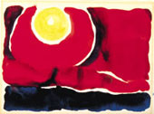
Figure 1

Evening Star No. VI, 1917
watercolor on paper,
8 3/8 x 12 in.

Figure 2
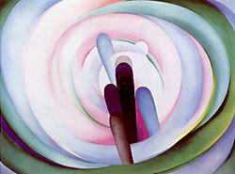
Grey, Blue and Black—Pink Circle, 1929
oil on canvas,
36 X 48 in.

Figure 3

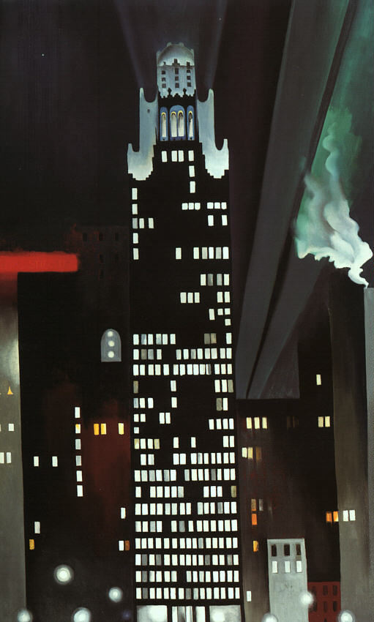
Radiator Building, 1927
Oil on canvas,
48”x 30”

Figure 4
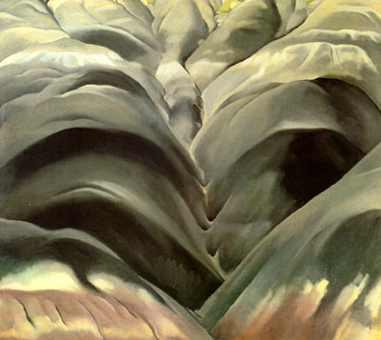
Black Place No. 1, 1944
oil on canvas,
26" x 30"

Figure 5

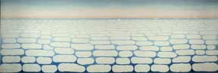
Sky Above Clouds IV, 1965
Oil on canvas
243.8 x 731.5 cm

