ART 12

Artist Research:
Judy Chicago (1939-?)
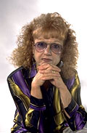

By:
Ginger Scott
Cycle A
Judy Chicago is a well-known feminist artist who is known to have influenced the uprising of the feminist art movement and has been personally influenced by many sexual, social and political conflicts throughout history.
She was born as Judy Cohen into a religiously suppressive family. Her father had broken a 23-generation tradition of rabbis in the family. Judy’s parents never educated her on the Jewish religion or the great history of their family surrounding Judaism. Later, upon marrying Donald Woodman (her third marriage) she began studying Judaism with her husband and discovered that it was evolved from feminism. She embraced its concept by reading and studying Jewish literature, theatre, art and history. Her newfound interest in Judaism effected her future artistic endeavors such as “The Dinner Party” and “The Holocaust Project: From Darkness into Light”.
All of Judy Chicago’s well-known works are large projects containing several smaller works unified in subject matter. Her first large work was called “The Dinner Party” (figure 1), it is an enormous piece in the shape of an equilateral triangle (48 feet on each of the three sides) and has art works done in numerous forms of media from glass work to oil paint to tapestry. It contains a large table covered in white cloths and holds 39 place settings each representing an historic personage, goddess or important woman in history. Each of the smaller works included act as a symbolic story telling of the history of women through out time, in the Western world. It is purely feministic in nature for it’s meant to convey and inform the public of the drastic struggles women have endured for their freedoms and liberties.
Around the time “The Dinner Party” was released for public viewing (in 1979) Judy Chicago had been investing a lot of time researching the history of women and discovered that there was no symbolic depiction of women giving birth at any time period throughout the history of art. “It was obvious that birth was a universal human experience and one that is central to women's lives. Why were there no images? Attracted to this void, I plunged into the subject.” (Chicago, Judy, www.judychicago.com.) She decided to interview actual women on the subject of their birth experiences since there was nothing to study on the subject in books. She discovered a great deal about the reality of birth and about the myths and stereotypes surrounding it. She wanted to create a historical landmark that dealt with the issue of birth, a subject that should be made clear to everyone because it is such a large part of life. “The Birth Project” was that landmark, presented in 1982. It is comprised of 80 individual works (figure 2) along with written conceptualizations explaining and informing the art consumer about birth, women’s lives and the art of needlework (of which all the pieces were constructed: needlework and crochet.) Chicago did not make any of the tapestries but designed them and commissioned a team of needle workers to create them.
Her next project was “Powerplay” (1983) which was a further expression of feminist views on the oppression of women. The work was based more on the cruelty of man and his capacities to kill and harm, not only other men but also women and children. With “Powerplay” Chicago illustrates the abilities of man to harm and to be evil. The entire work seems to portray men in a very negative light but Chicago has recriminated: “I've never been anti-male. I've had deep, profound connections with men. They're not the enemy. I wanted to show them as humans, but acting in ways that are intolerable." (Chicago, Judy, www.judychicago.com). A lot of the works (most done in oil paint and acrylic) are very passionate pieces with expressive motion, bold lines and vibrant colours. (figure 3)
Chicago’s most recent project is “The Holocaust Project: From Darkness into Light” (1989) was directly inspired by her Jewish heritage and the study of its history. But, this project did not solely deal with the Holocaust of the Second World War but with all of the inhumanities against societies throughout history, and with the human condition, past present and future. This project was the result of a combined effort between Chicago and her husband, Donald Woodman, a photographer. The project consists of 13 large-scale tableaus, which are combinations of Chicago’s painting and her husband’s photos. (figure 4) The unorthodox arrangements of the medias evoke great emotions of empathy and hurt for your fellow human and the struggles against injustice they have overcome.
Today Judy Chicago is the founder of “Through the Flower”, a non-profit organization based on the education, preservation and exhibition of her work and the important visions and messages that her work conveys. Her work is not just beautiful to absorb visually but it also carries a great message, and an intelligent wisdom about the struggles of not only women, but of human being as a whole.

Figure 1
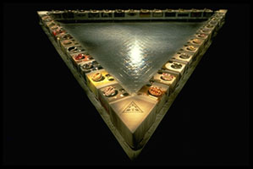
“The Dinner Party”
Mixed media, 48' x 42' x 3'
Judy Chicago 1979

Figure 2

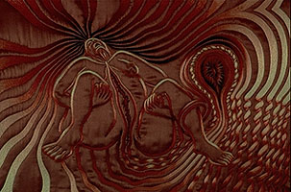
“Birth Tear”
Embroidery on silk, 27 1/2" x 33 1/2".
Needleworker: Jane Thompson
From “The Birth Project”
Judy Chicago 1982

Figure 3

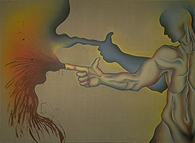
“In the Shadow of a Handgun”
Sprayed acrylic and oil
on canvas, 9" x 12'
From “Powerplay”
Judy Chicago 1983

Figure 4
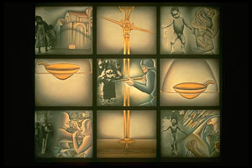

“Im/Balance of Power”
Sprayed acrylic, oil and
photography on
photo linen
6' - 5" x 7' - 11".
From the Holocaust
Project
Judy Chicago 1989

Bibliography

- http://www.judychicago.com (December 8, 2001)
- http://jewishsf.com/bk960614/bnajudy.htm (December 8, 2001)
- http://www.mum.org/armenjc.htm (December 8, 2001)

