Art 12

Contextual Self Portrait

Process Task (in total, make 5 responses to portrait images in your journal)
- Collect images of self identity. Images you may have already shot. (consider clips from videos, Facebook images, drawings, etc).
- Take some of these images and print at least three of them and put images in sketchbook . In your sketchbook, deconstruct what your expression, clothing, context etc means in each image. Discuss and assess its meaning. Explore ‘self’ in form and identity; your contributions to society; what you take from society; your emotional expressions; clothing and context.
- Do the same with an image of a friend.
- Take short video... Selecting a specific frame, print and respond to the most informative frame.
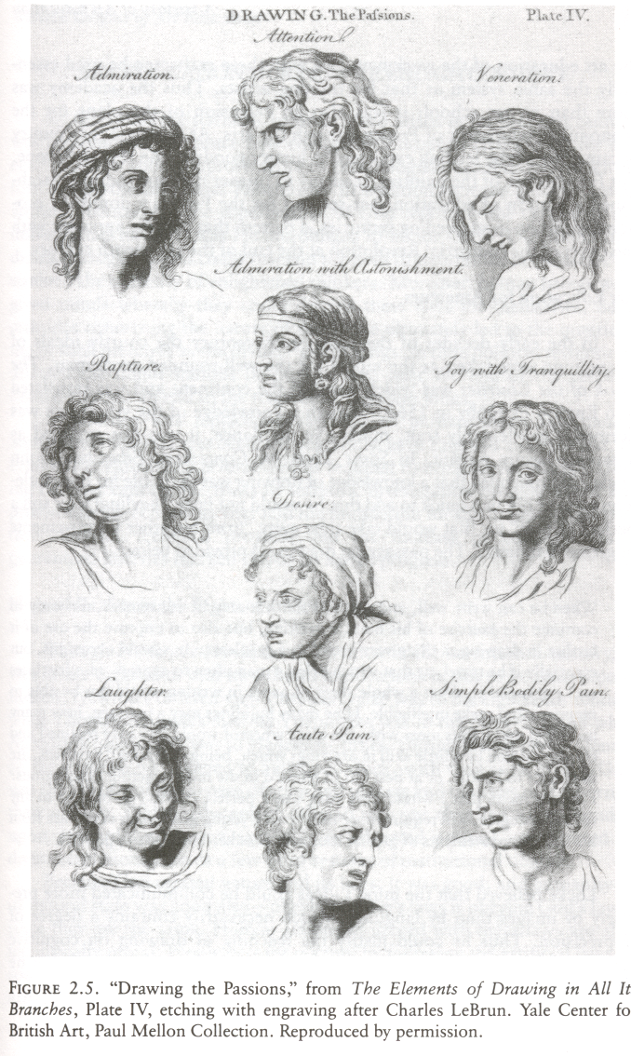

Product Task
Create a large scale self portrait in a place. Choose a relevant media that will allow you to focus on value – not colour...

Or in other words….
Create a representational self-portrait that evokes meaning through the placement of your figure in a context and through your figure’s kinesthetic and facial gestures.
Pay particular attention to:
- The figure’s context / environment for meaning
- Controlled lighting
- Compositional arrangement of figure on the ground.
- How you choose to describing form, light & texture
- The expressive qualities of your medium and treatment
- Scale

Materials
If a drawing or painting, we have Stonehenge 22x30 and larger. We can also offer video and picture cameras. The rest, get resourceful.

Self Portrait in Context Assessment: Art 12

Level 4  90-100 | Demonstrates high competency in the art making process and was able to express a unique visual art idea that engages an audience. We are seeing something that is fully resolved and potent in concept and form.  This happened through:  - Meeting or Exceeding all of the Level 3 criteria  - This artwork is ambitious and potent in form and concept, engaging a critical audience in a new or otherwise dynamic way.  - Colour may have been used very successfully.  - Substantial risks or challenges were taken and it worked!
Level 3  80 | Demonstrates a capacity to observe and draw a self portrait that accurately reflects the your form. The figures posture and environment are considered to create a drawing that can be described as a creative and engaging self portrait.  Planning Process:  - RESEARCH: 5 images explored in the sketchbook and deconstructed (assessed) in writing and sketches.  - EXPLORATION:.Planning of compositions, meaning and medium for larger work.. Do studies from a mirror.  Product:  - Then concept is innovative or creative, clearly a product of your insights & subsequently engaging a critical audience in some form of dialogue. It is meaningful. Creative Risk taking is encouraged.  - The drawing models a strong effort to capture the likeness of yourself using a mirror.  - The medium is used in a way that models competency and understanding the medium’s expressive/communicative qualities.  - The context is well considered and executed. The whole image feels complete and engaging.  - The composition is activated to steer the viewer’s eye and to support the work’s intent.  - The artist has taken on a challenge. Risk taking is evident in form, media, content, and or scale.  - The artist shows considerable commitment to their project. There is evidence of ambition and rigor in the process & product.  Perceiving & Responding:  - The student has reflected on the intent, meaning and relevance of their art work as evident in a typed and edited reflection (including an appropriate title). Aspects of an inspirational artwork are identified and connected to your work.  - Makes meaningful contributions in critiques, involving analysis and critical judgments or probes

Level 2  60 | The artwork demonstrates basic competency in art making. Core skills and sensitivities are modeled. The following factors may apply…  Planning Process:  - There are some preliminary sketches  Product:  - The Concept is clear and somewhat innovative. The artwork retains some level of meaning beyond the level of a study.  - The figure may be well rendered, but the environment lacks consideration or resolve. The artwork models a fair skill level.  - Care and respect for the concept and media are modeled  - The composition may need more consideration – to engage the eye  - Some risk taking has occurred  - The scale meets basic conventional considerations (e.g 18”x24” or larger for a drawing or painting)  - The art work is somewhat complete.  - The forms are refined or treated rendered to suit the artistic process.  Perceiving and Responding:  - A basic artist statement that outlines the artist’s intent and process has been submitted.  - Participates in critiques chiefly when prompted and sticks mainly to descriptive analysis.
Level 1  40 | Some of the criteria of level 2 were achieved, though key aspects were missing. The following factors may apply…  Planning:  - There is little to no evidence of preliminary sketches /planning  Product:  - The artwork is a study, it lacks meaning  - Elements and principles appear unconsidered  Perceiving & Responding:  - No artist statement submitted  - Doesn’t participate in critiques, even when prompted
Level 0  35 and under | Even with support available, the project lacked basic preparedness and understanding.

